A PROJECT REPORT ON

Restaurant's - Foodie Prediction System

**FOR**

**FYRA INSIGHTS PVT LTD**



By

**Miss Mayuri Bhimashankar Dhanwate**

IN PARTIAL FULFILMENT OF THE REQUIREMENTS

FOR THE AWARD OF THE DEGREE OF

**MSc Tech(IMCA)**

**UNIVERSITY OF PUNE**



**NOWROSJEE WADIA COLLEGE**

**PUNE-411001(2018-2019)**

**Acknowledgement**

**I have great pleasure in presenting this report on “Restaurant foodie prediction system” and to express my deep regards towards those who have offered their valuable time and guidance in my hour of need.**

**I would like to express my sincere and whole hearted thanks to Mrs Rohini Khot who has contributed immensely in successful completion of project work**

**I am also glad to express thanks to my parents and friends for their constant inspiration and encouragement.**

**Finally before ending I would like to express once again my gratitude and thanks to all those who are involved directly and indirectly in making my project a success.**

**I sincerely thank Mr Sopan Shewale (Director of FYRA INSIGHTS PVT LTD) for their support and guidance they provided throughout an internship period.**

**Miss Mayuri Bhimashankar Dhanwate**

**Table of Content**

[Introduction](https://docs.google.com/document/d/1eQrXeD6cUu555QvsMXdZhzt3Ofs-Uk_yR3l2HvoHlHM/edit#heading=h.5f3fnol3pb4s)

Company Profile

[Problem Statement](https://docs.google.com/document/d/1eQrXeD6cUu555QvsMXdZhzt3Ofs-Uk_yR3l2HvoHlHM/edit#heading=h.fdvgc573hivi)

Existing System

Proposed System

Feasibility Study

[Approach to Sol](https://docs.google.com/document/d/1eQrXeD6cUu555QvsMXdZhzt3Ofs-Uk_yR3l2HvoHlHM/edit#heading=h.dkuj9pnnkrkc)v[e the Problems](https://docs.google.com/document/d/1eQrXeD6cUu555QvsMXdZhzt3Ofs-Uk_yR3l2HvoHlHM/edit#heading=h.dkuj9pnnkrkc)

[Technologies Used](https://docs.google.com/document/d/1eQrXeD6cUu555QvsMXdZhzt3Ofs-Uk_yR3l2HvoHlHM/edit#heading=h.eyqtpwu2gl0i)

[Web Application - Prediction](https://docs.google.com/document/d/1eQrXeD6cUu555QvsMXdZhzt3Ofs-Uk_yR3l2HvoHlHM/edit#heading=h.noy90m8ito15)

[Machine Learning Algorithm](https://docs.google.com/document/d/1eQrXeD6cUu555QvsMXdZhzt3Ofs-Uk_yR3l2HvoHlHM/edit#heading=h.d1wz8fckr2ti)

[Data Simulated for the Project](https://docs.google.com/document/d/1eQrXeD6cUu555QvsMXdZhzt3Ofs-Uk_yR3l2HvoHlHM/edit#heading=h.ct82692evvl3)

Schedule of work

Required diagram

[Application - Demonstration](https://docs.google.com/document/d/1eQrXeD6cUu555QvsMXdZhzt3Ofs-Uk_yR3l2HvoHlHM/edit#heading=h.pdi415vrjbva)

[Highlights on Challenges](https://docs.google.com/document/d/1eQrXeD6cUu555QvsMXdZhzt3Ofs-Uk_yR3l2HvoHlHM/edit#heading=h.pkhmc5i5cnlo)

What’s [Next?](https://docs.google.com/document/d/1eQrXeD6cUu555QvsMXdZhzt3Ofs-Uk_yR3l2HvoHlHM/edit#heading=h.oiuzliyowa35)

[References](https://docs.google.com/document/d/1eQrXeD6cUu555QvsMXdZhzt3Ofs-Uk_yR3l2HvoHlHM/edit#heading=h.y81r4avnehhl)

# **Company Profile**

●Fyra Insights Private Limited is a Private incorporated on 11 July 2017. It is classified as Non-govt company and is registered at Registrar of Companies, Pune.

● Its authorized share capital is Rs. 50,000 and its paid up capital is Rs. 50,000.

● It is involved in Other computer related activities [for example maintenance of websites of other firms/ creation of multimedia presentations for other firms etc.]

●We sale CRM for Restaurants.

●We are a company of skilled Engineers, Accountants, Lawyers, Mathematicians and Investors.

Our goal is to provide simple tools for businesses of any size

•whether they are small mom and pop shops or established

•businesses. We believe that the tools which are mainly

•accessible to large businesses should be available for

•everyone, and there shouldn’t be a need to pay licensing or

•per user fees. We also hope to bring the businesses into the

•mobile world so their operations can be run from a simple

•smartphone all the way to a desktop!

# **Problem Statement**

The restaurant industry is totally unpredicted when it comes to understand customer behaviour. Making food ready for number customers which they don’t know how many may visit on certain day, certain time may endup making losses to the restaurant owners.

If they know exactly how many customers visit, it will help them to cook food accordingly and help them give better experience to the customers.

The current generation is totally driven by data - if we can use some machine learning or artificial intelligence tools based on the historical data about restaurant customers, we should be able to predict approximately number of visitors. That will help restaurants prepare appropriate amount of food, helping them convert losses into profits.

In this project - we are attempting to develop Machine Algorithms and System which can help predict number of visitors to a restaurant.

**Approach to Solve the Problems**

We will explore the problem in following stages:  
**Creating dummy data**

Our project not based on real scenareo so that we prepared our own dummy data for restaurant. we included all those features in our data which will be useful for us to learn and implement algorithms in better way .

It was our duty to create dummy data using readymade tools like faker package .we have taken only those features which are useful for prediction purpose.

**Feature Engineering**

modifying existing variables and creating new ones for analysis. For this purpose also we have too many inbuilt libraries which we have used here for creating new columns using existing columns .

**Model Building**

making predictive models on the data.we made predictive model using two algorithms

Linear regression

Logistics regression

Both the model approximate equal accuracy .so we can choose any of them as best for our project

**Feasibility study**

Feasibility and risk analysis are related in many ways .if project risk is great,the feasibility of producing quality software is required.

It is one of the system analysis usually involves a through assessment of the operational , financial and technical aspects of a proposal.Feasibility study is the test of the system proposal made to identify whether the user needs may be satisfied using the current software and hardware technologies, wheather the system will be cost effective from a business point of view and whether it can be developed with the given budgetary constraints.A feasibility study should be relatively cheap and done at the earliest possible time. Depending on the study ,the decision is made whether to go ahead with a more detailed analysis.

# 

# 

# 

# 

# **Technology Used**

**Programming language-**

Python 3.7.2

**Framework-**

**Django** 2.1.5

# 

# 

**Web Application Prediction**

We have created web application using Django framework.first off all we read Django documentation and then start doing work we have created many small small web applications which are able to predict something .

Initially in training period we have created web application in Django which has a basic look and feel in that application there is a dataset which has all the information about home like it's location , price etc

That application predict what will be the price of home if all other attributes we know

After that we have created again small basic application which uses API for the prediction which takes location as a input and which gives information regarding weather in that specific location.

Finally we concentrate on our main prediction problem after completion of training.we have collected large amount of data form restaurant which is of last two years .which contains all the information about restaurant as well as all the previous customers and their feedback for that particular restaurant

Then we proceed, Our main goal in this project is to predict number of foodie visiting on given day or date .for this we use machine learning algorithm

# **Machine Learning Algorithm**

**Linear regression**

We use linear regression for prediction.Linear regression is a machine learning algorithm using which we build a model and then we train our model using training data . machine is now able to predict in future .

Also machine learns from previous experiences.prediction data is getting stored in as a new entry and size of data goes on increasing.As data becomes large and large accuracy also increases,that mean there is a directly proportional relationship between amount of data and accuracy of the prediction.

In linear regression there are two variables one is dependent variable and another is independent variable .if we know value of independent variable then we can predict value of dependent variable using trained model

Before actual prediction we test our model using testing data .if accuracy is enough then we are done but if not then we use another algorithm for getting more accuracy .also we can add some features or delete some features to get accuracy near about 100%

**Data Simulated for the Project**

Our project is not real scenario based project .so that we have created dummy data using faker package .also we have taken only those features of customers which can help us to predict number of customers .

Because data is created by us there is no need to clean data that step is already done .

Our data has features like customers name , mobile number ,intime,outtime ,PAX,and date. In this PAX is a feature which tell us how many people are there with customers coming in restaurant.

**Application - Demonstration**

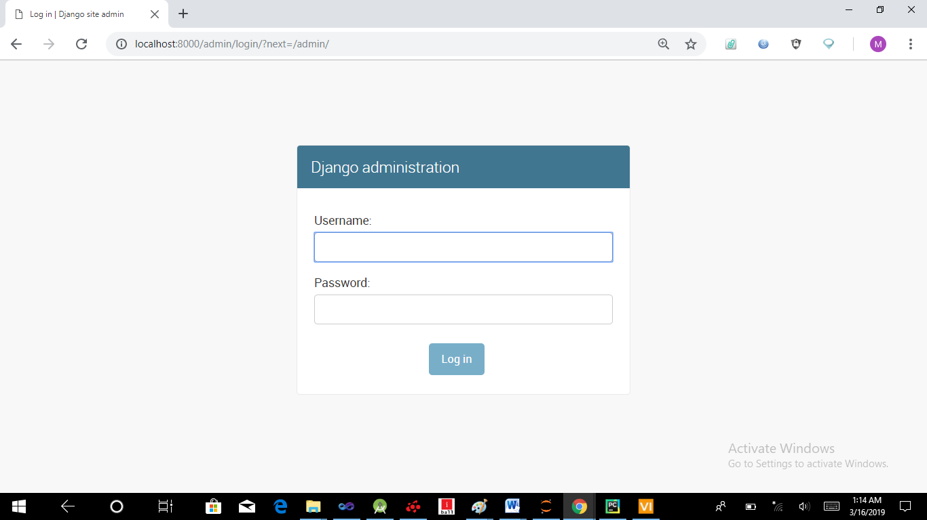

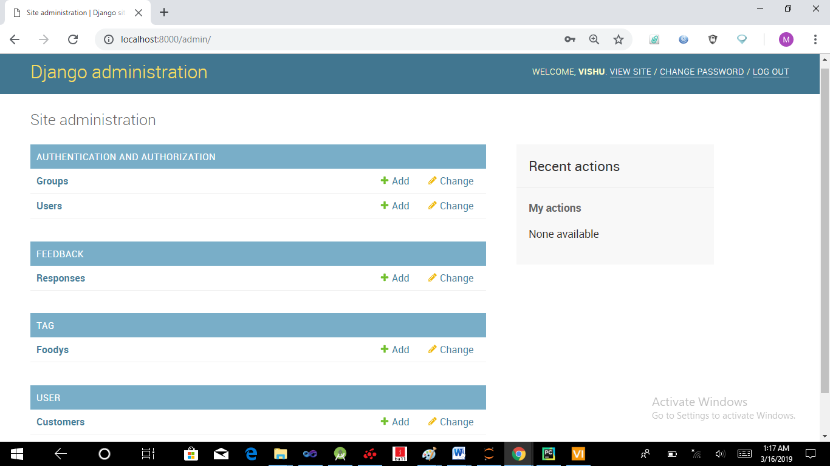

* 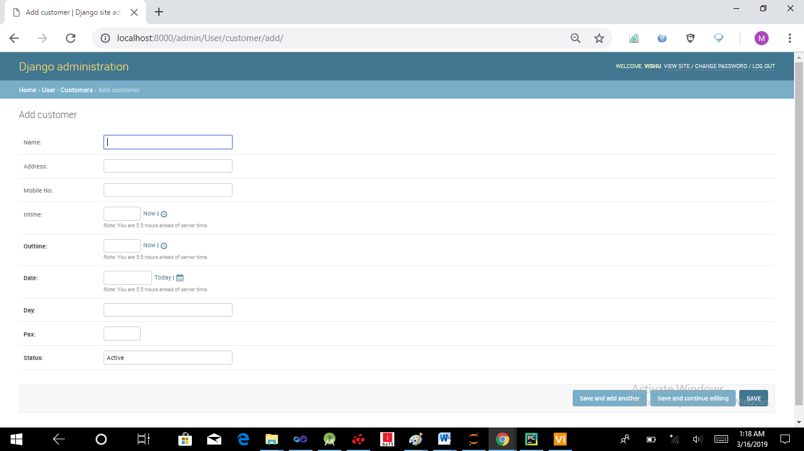

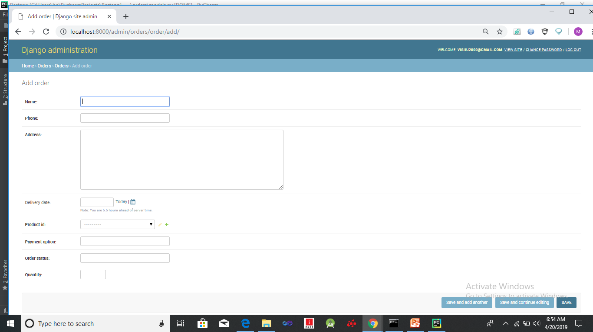

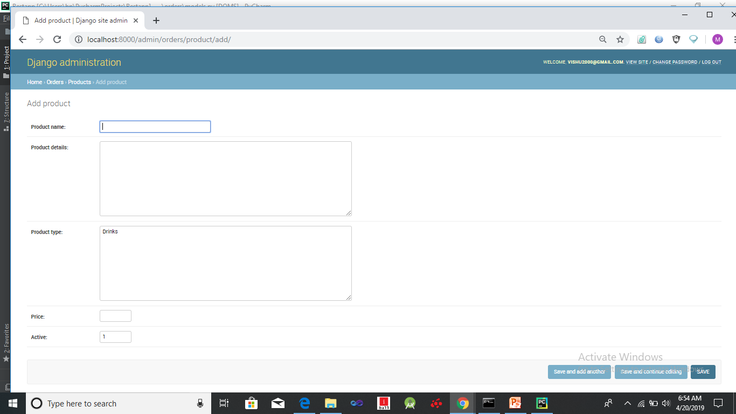

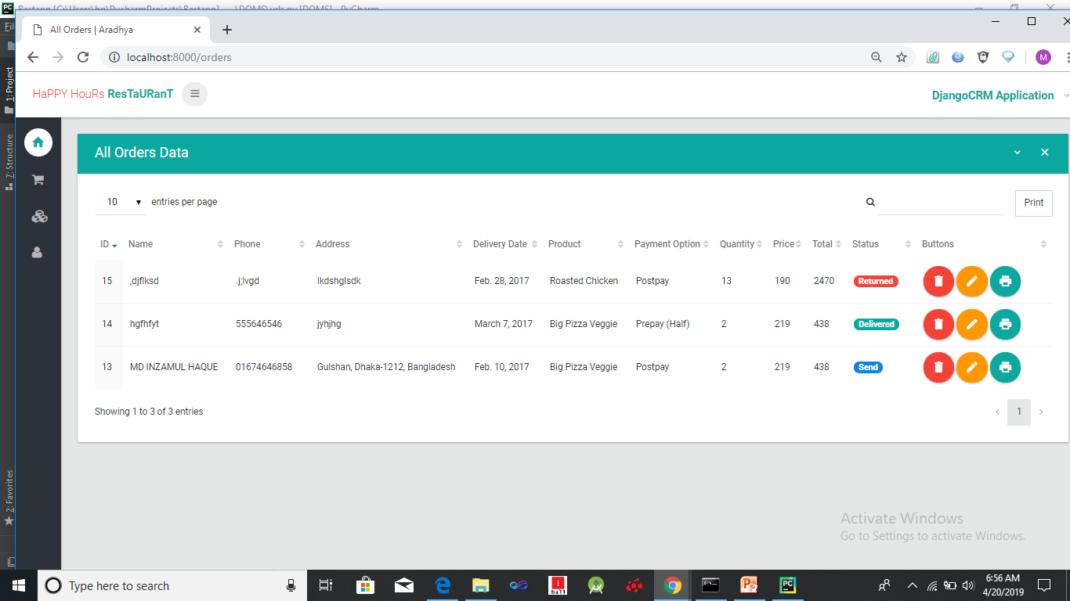

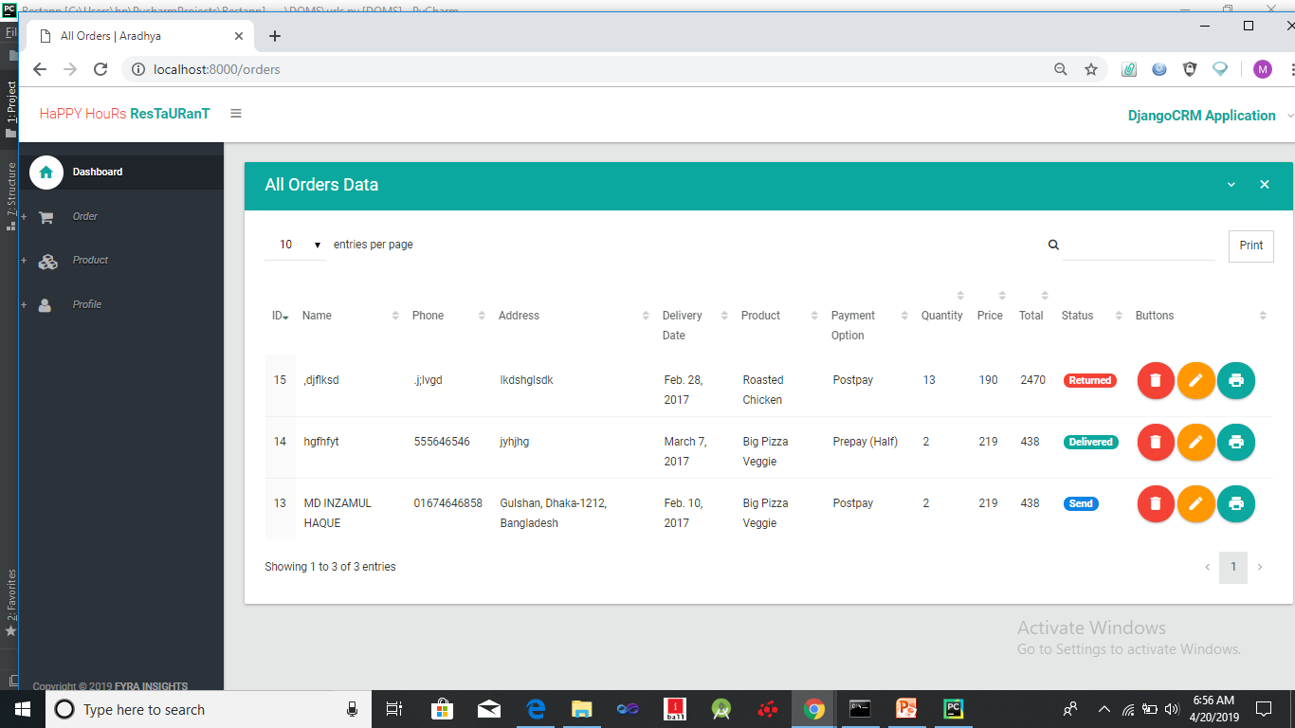

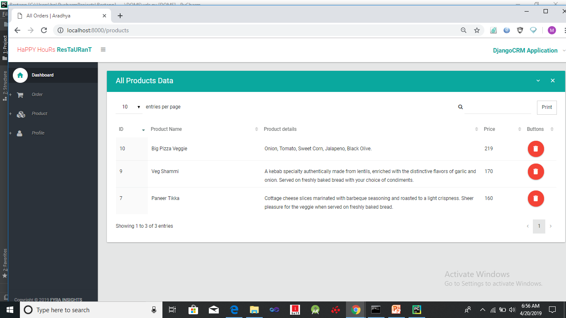

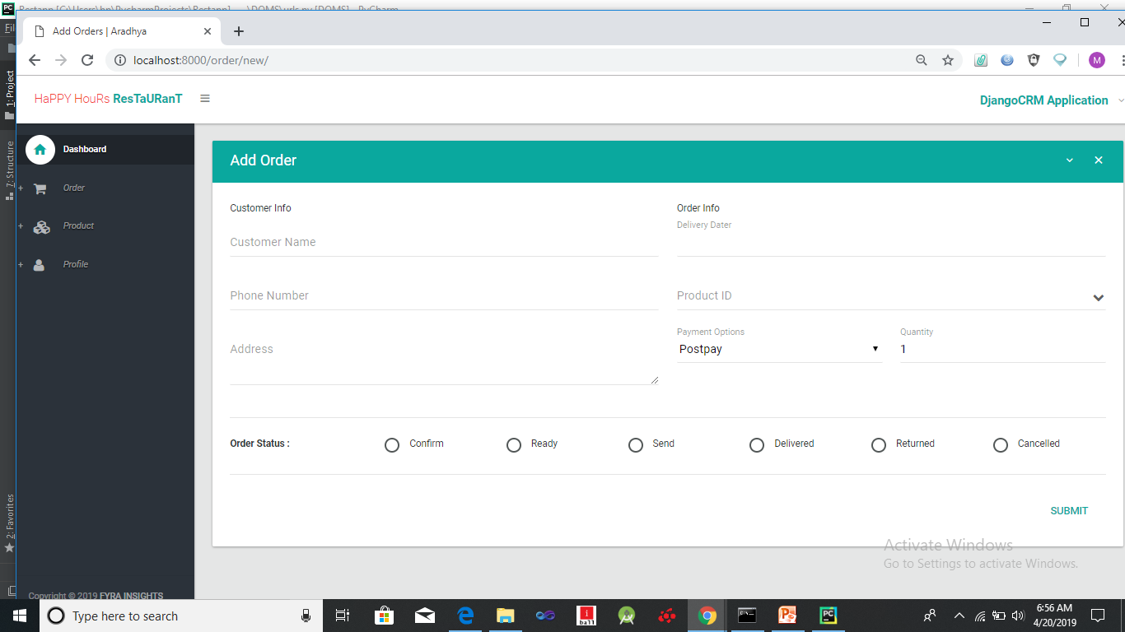

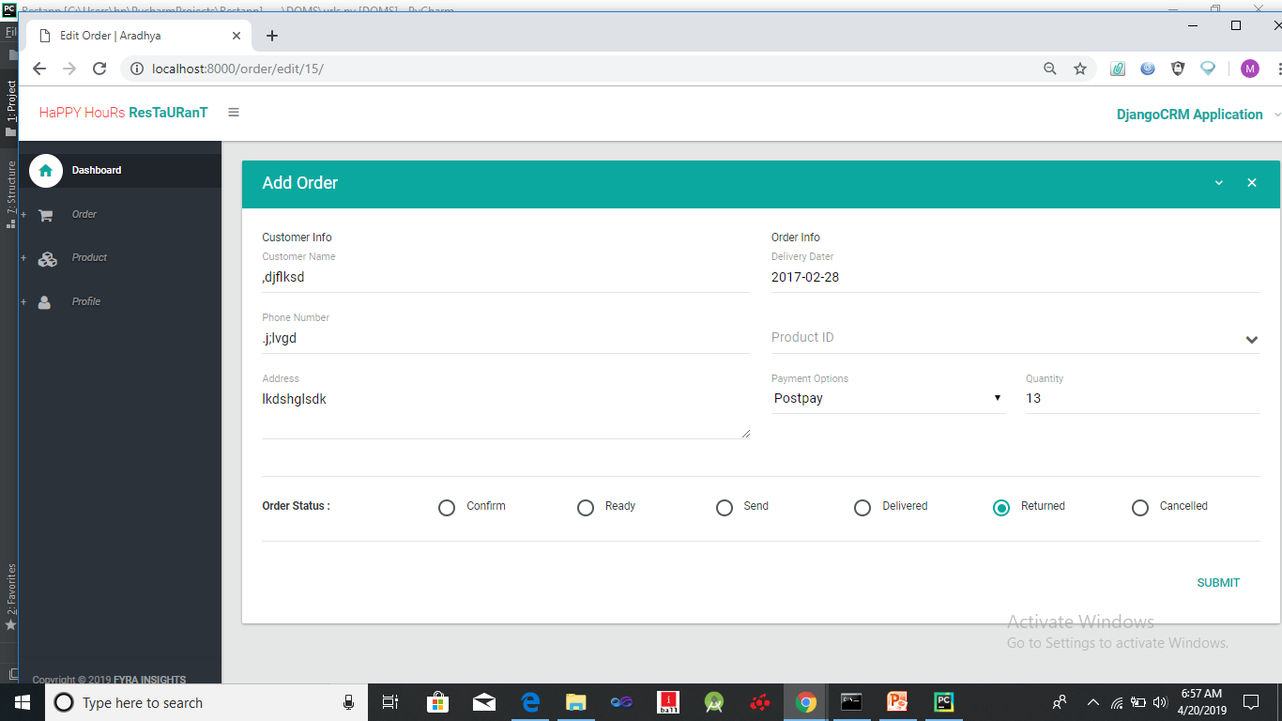

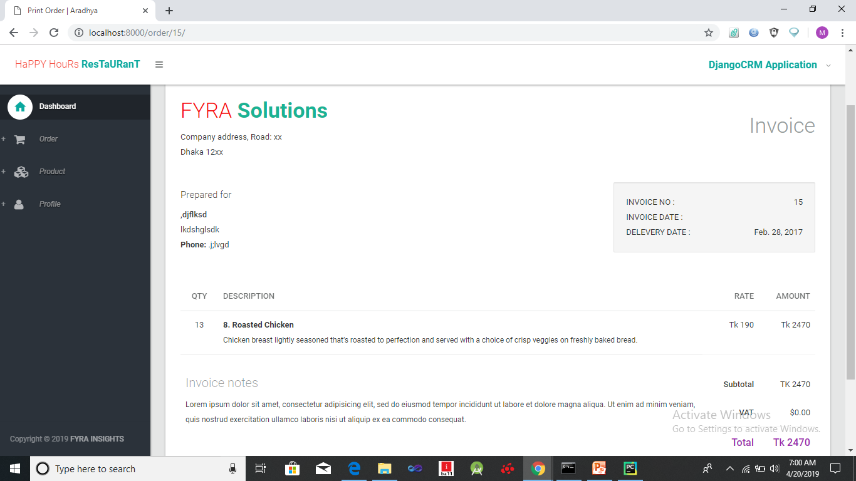

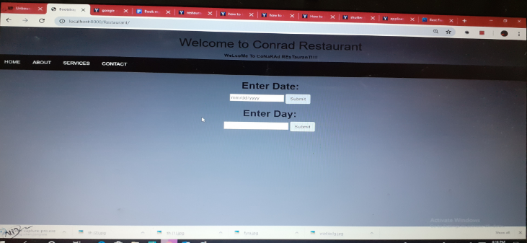

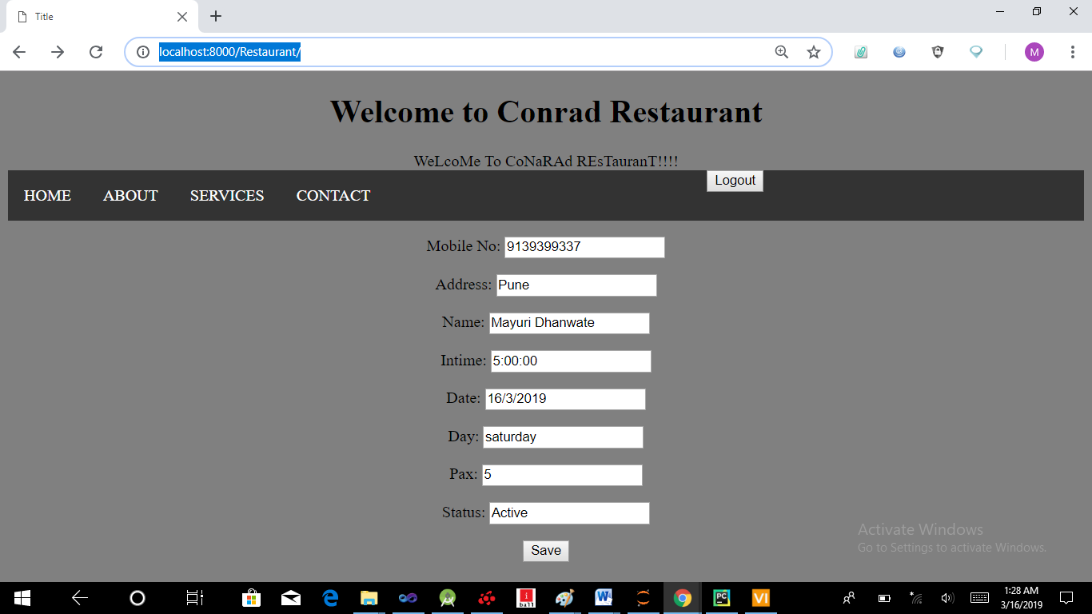

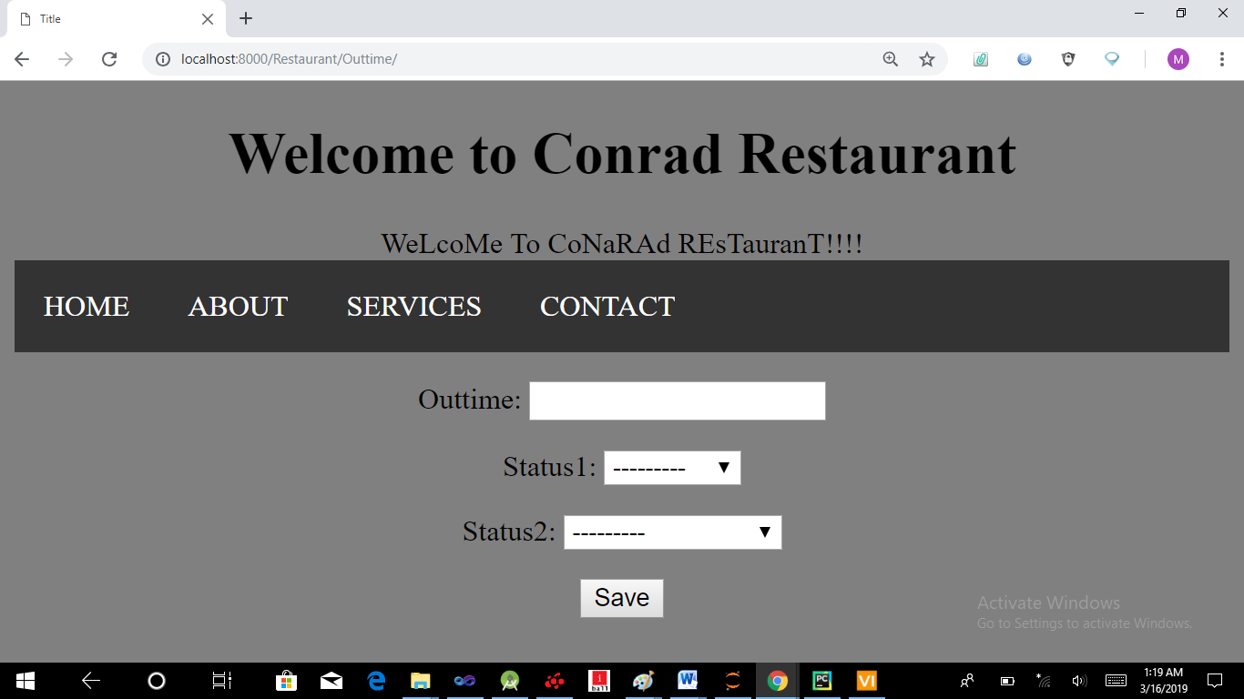

# **Schedule of work**

# 

# 

| Month | Work |
| --- | --- |
| December | Training on Python |
| January | Training on Django framework |
| February | Web Application project |
| March | Machine learning algorithms  Linear regression |
| April | Prediction |
| May | Report |

# 

# **Required Diagrams**

# 

# 

# 

# 

# 

# 

# **Highlights on Challenges**

* **Creating web application:**

First off all creating basic web application for our project was a challenge for us.

* **Creating dummy dataset:**

Next challenge was how to collect large amount of data for restaurant which we can use for prediction purpose

* **Extraction of features from data:**

After collecting data next challenge was to clean that data and remove those features which will not involved in the prediction.

* **Applying machine learning algorithm:**

After extraction of features the next challenge was to decide which algorithm we can choose so that we will get best result of prediction.

# 

**Limitations**

System is applicable for valid Mobile number users

In this system we able to know which customer is coming on which date day and also time .as well as with how many people he or she is going to come in restaurant

It is web based so it requires browser to run this application.

# **Future Enhancement**

Now this application works for only one restaurant. In future it can be extend to work for many restaurants.next we can extend our application in such a way that it will predict which restaurant is best for specific customer by taking customer's basic information as a input.

In this project we are not giving different different online payment options for customers when he our she order some food from restaurant.that we can do next as improvement.

Also we can recommend restaurant for customers through our Application

# 

# **Conclusion**

The result of the project is described from the perspective the aim and scope set in the beginning of the thesis .the ideas for future web based project management system are also described here.

The aim of the project was to make a complete ,fully web based restaurant foodie prediction system for the restaurant . Requirements from the restaurant has been gathered and taken into account.In web based restaurant foodie prediction system to improve restaurant's everyday use and to increase performance, productivity and efficiency.

As a good restaurant foodie prediction system it has a possibility to predict number of customers coming in restaurant.

# 

# 

# 

# 

# 

# **References**

website: [www.pytho](http://www.python)n.org.in

[www.kaggle](http://www.kaggle).com

Introduction to machine learning with python .

Documentation:

Python documentation

Django documentation